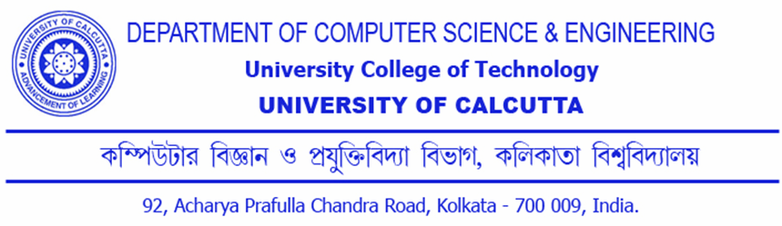

CERTIFICATION
This is to certify that the dissertation entitled “A Treatise on the uses of Voronoi diagram and Delaunay Triangulation in Art Gallery problem” is the bonafide work of Subhajit Setua and has been prepared according to the regulations for award of the degree of Master of Technology in Computer Science and Engineering in University of Calcutta for the year 2011 and the candidate has partially fulfilled the requirements for the submission of the dissertation.

………………………………..……………. Prof. Devadatta Sinha Project Supervisor-Comp. Sc. & Engg. Dept., CU
………………………………………………. Prof. Nabendu Chaki, Head of the Dept., Comp. Sc. & Engg. Dept., CU
……………………………………….

